**Individual Report**

## —— Health Record

## By Zhang Yining(55541587)

### /var/folders/4v/bm4w97cn1ll87kgsqg0ltjhw0000gn/T/com.microsoft.Word/WebArchiveCopyPasteTempFiles/15532547670292.jpg/var/folders/4v/bm4w97cn1ll87kgsqg0ltjhw0000gn/T/com.microsoft.Word/WebArchiveCopyPasteTempFiles/15532530587738.jpgThe main page - BMI Page

* The user can calculate and commit their BMI to the SQLite.
* Use the SharedPreferences to remember the last input.
* Based on the BMI calculated, the text and text color will change automatically.

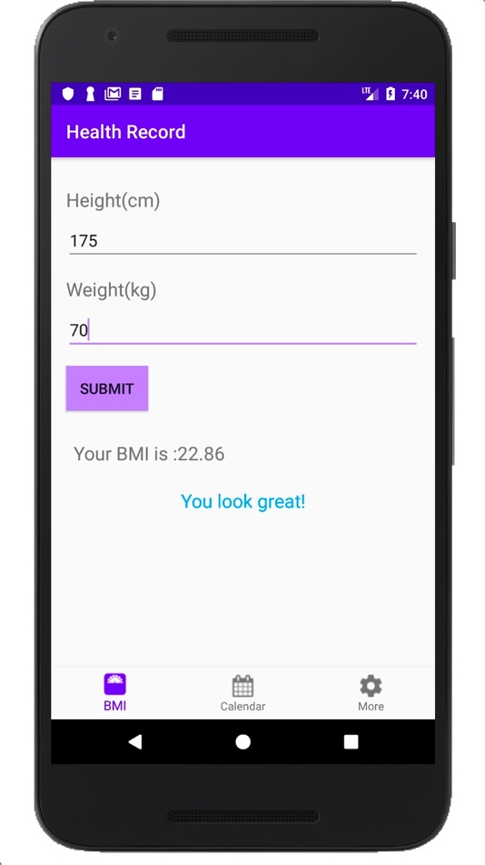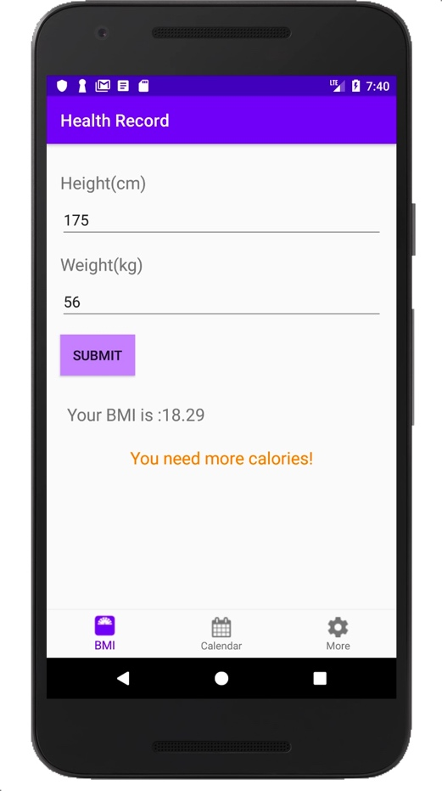￼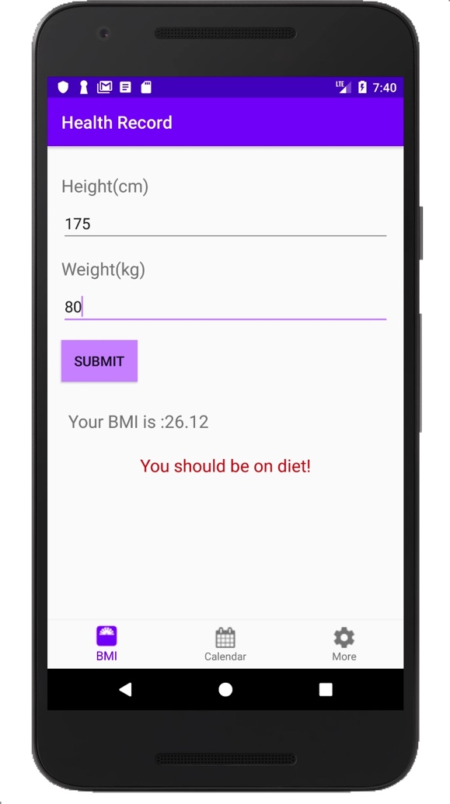￼

* If the user forgets to fill in the "Height" and "Weight", it will give a "Toast" to warn the user.
* 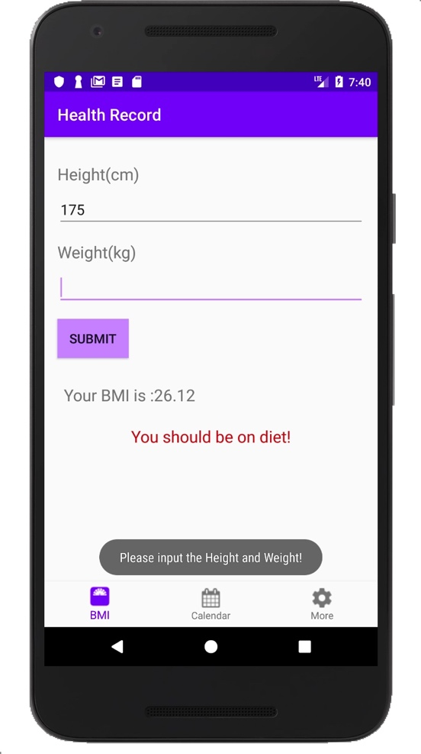￼

### The Calendar Page /var/folders/4v/bm4w97cn1ll87kgsqg0ltjhw0000gn/T/com.microsoft.Word/WebArchiveCopyPasteTempFiles/15532530656210.jpg/var/folders/4v/bm4w97cn1ll87kgsqg0ltjhw0000gn/T/com.microsoft.Word/WebArchiveCopyPasteTempFiles/15532548759115.jpg￼

* If there is a record of BMI, there will be a plot under the date.
* The user can click the date to get the BMI at that date.
* 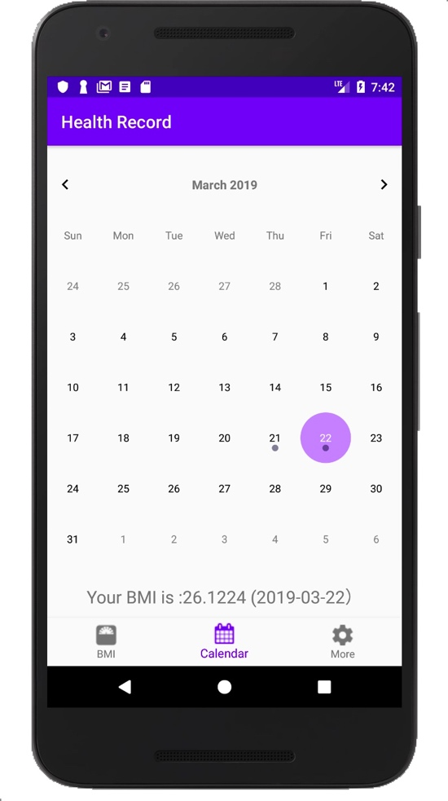￼

### Setting Page /var/folders/4v/bm4w97cn1ll87kgsqg0ltjhw0000gn/T/com.microsoft.Word/WebArchiveCopyPasteTempFiles/15532530733851.jpg￼/var/folders/4v/bm4w97cn1ll87kgsqg0ltjhw0000gn/T/com.microsoft.Word/WebArchiveCopyPasteTempFiles/15532546967516.jpg￼

* Can change the language without setting the System's Language.

### Main Code

* Use the Navigation at the bottom. As a result, I don’t use intent to transfer the message, instead I use fragment to do the UI.

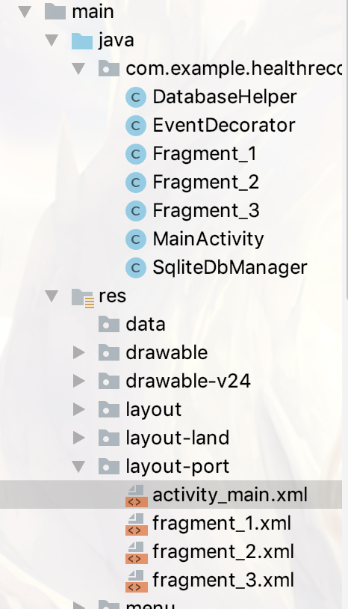

* When the users click on the button, the fragment is replaced by 3 different views. 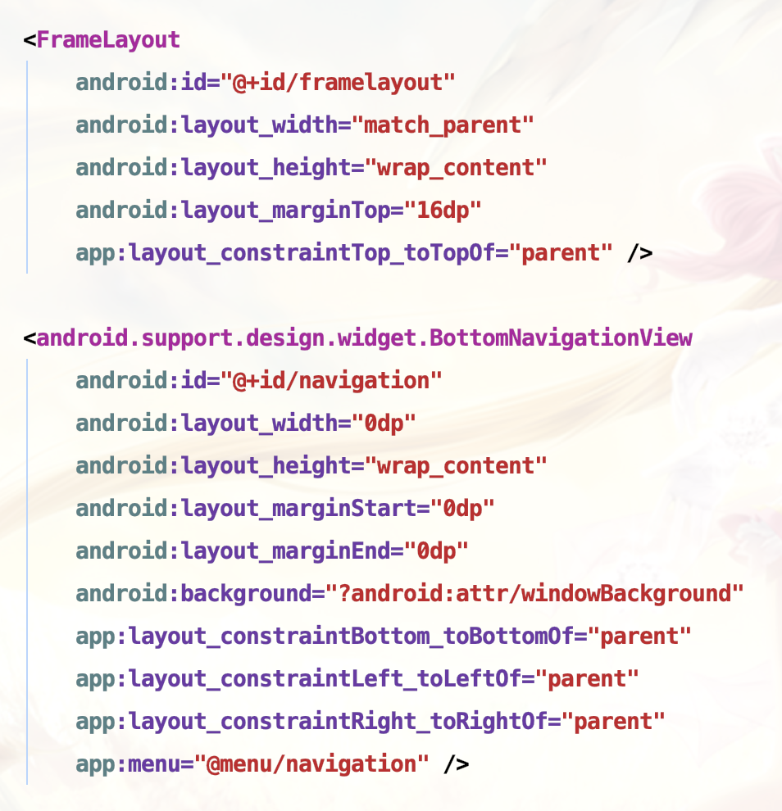
* I use a SQLite to record the data of the BMI, and use calendar to get them from the SQLite and display on the screen. If you see a “dot” on the date, it means that there is a record on that date.

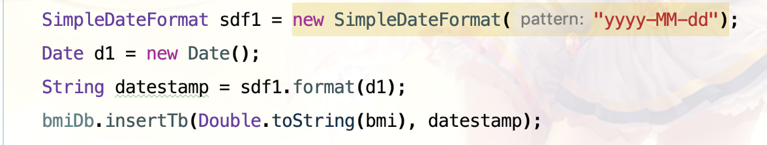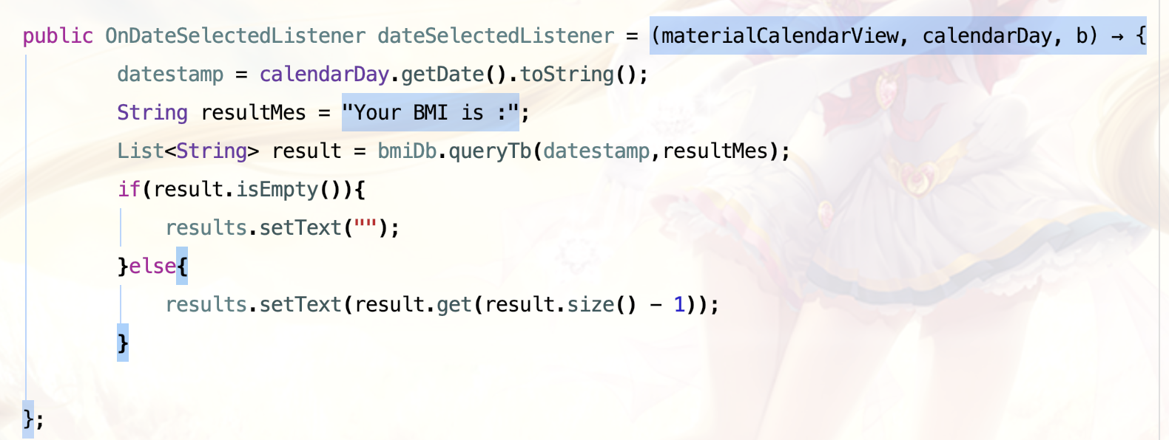

I redo the “BMI” App with my own UI and code design. I think this app does not have so many powerful method but it is really useful and well-designed.